# 1) How to Set Up a Website on a Local System and a Server (Step-by-Step)

1. After downloading the repository from GitHub, you’ll find three folders: **Code**, **Database**, and **Documentation**.
2. The **Code** folder contains the project files.
3. The **Database** folder contains the .sql file.
4. Inside the **Documentation** folder, you’ll find a Word file that explains how to deploy the website on both the server and the local machine.

# 2) Steps to set up the website on the server

1. Open the server and navigate to the path:

/var/www/html

Copy all the files from the **Code** folder into this directory.

1. Open **phpMyAdmin** and log in (as shown in the screenshot provided). 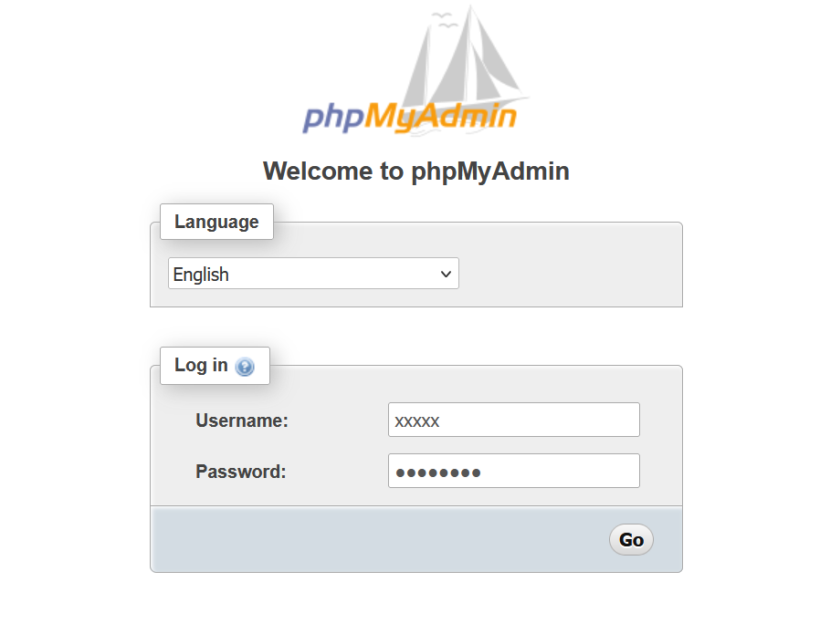
2. After logging in, phpMyAdmin will open in the GUI (see screenshot).
3. Create a new Database

• Either create it manually through the GUI, **OR**

• Go to the **SQL** tab, paste the following query,

(create database databasename) and click **Go**:

1. After creating the database, select it and open the **Import** tab (screenshot provided).

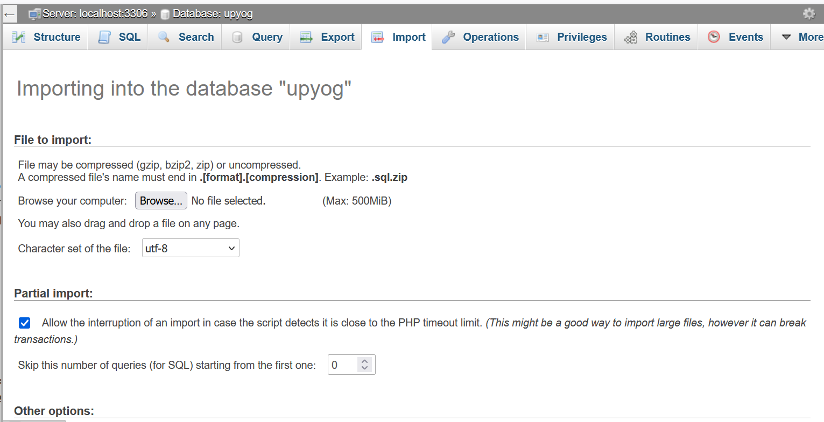

1. Click the **Browse** button, go to the **Database** folder, select the upyog.sql file, and click **Go**. Wait for the process to finish — the database will be imported successfully, and all the tables will appear in phpMyAdmin. 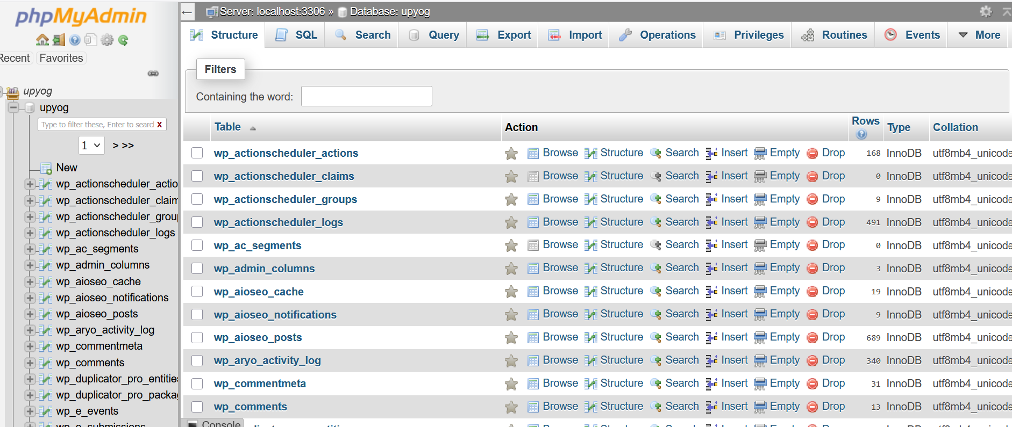
2. Once the database is imported, you need to update the old URL with the new URL throughout the database.

* Example:
  + **Old URL:** http://15.207.2.81/upyog
  + **New URL:** https://xyz.com
* Replace new_url with your actual domain name in the following commands, then paste them into the **SQL Command Line Query** in phpMyAdmin and click **Go**:

UPDATE wp_options SET option_value = REPLACE(option_value, 'http://15.207.2.81/upyog', 'new_url') WHERE option_name = 'home' OR option_name = 'siteurl';

UPDATE wp_posts SET guid = REPLACE(guid, 'http://15.207.2.81/upyog','new_url');

UPDATE wp_posts SET post_content = REPLACE(post_content, 'http://15.207.2.81/upyog', 'new_url');

UPDATE wp_postmeta SET meta_value = REPLACE(meta_value,'http://15.207.2.81/upyog','new_url');

UPDATE wp_usermeta SET meta_value = REPLACE(meta_value, 'http://15.207.2.81/upyog','new_url');

UPDATE wp_links SET link_url = REPLACE(link_url, 'http://15.207.2.81/upyog','new_url');

UPDATE wp_comments SET comment_content = REPLACE(comment_content , 'http://15.207.2.81/upyog','new_url');

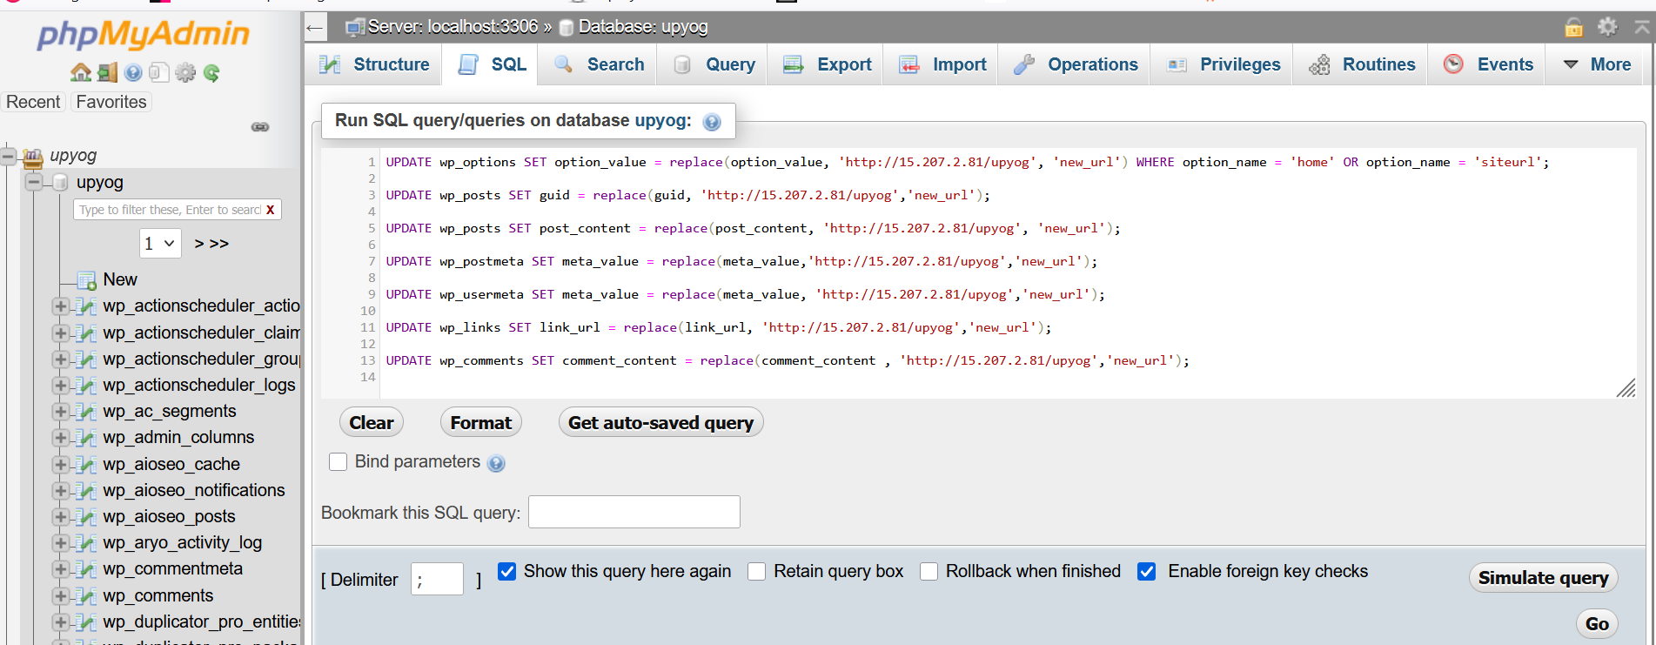

1. To confirm that the URL has been updated, run the following queries to check your **site_url** and **home_url**:

SELECT * FROM wp_options WHERE option_id = 1;

SELECT * FROM wp_options WHERE option_id = 2;

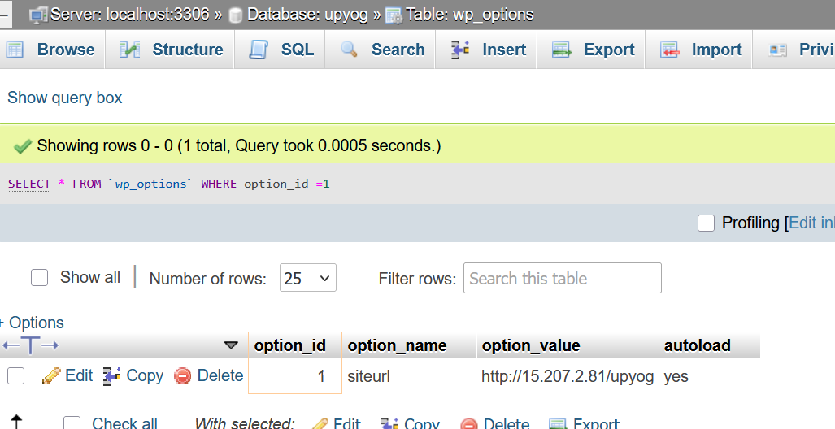

1. **After completing the database configuration, connect the database to your code to the database.** Go to the **root directory** and open the wp-config.php file. Update the database configuration values as shown below (replace with your actual database details):

**/** Database name */**

**define( 'DB_NAME', 'your_database_name' );**

**/** Database username */**

**define( 'DB_USER', 'your_database_username' );**

**/** Database password */**

**define( 'DB_PASSWORD', 'your_database_password' );**

**/** Database hostname */**

**define( 'DB_HOST', 'localhost' );**

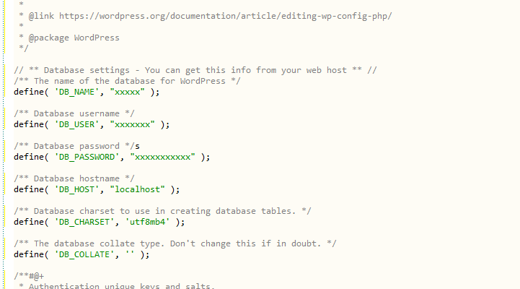

10). After completing the connection between the database and the files, go to the root directory and open the .htaccess file. Paste the following code into it:

# BEGIN WordPress

RewriteEngine On

RewriteRule .* - [E=HTTP_AUTHORIZATION:%{HTTP:Authorization}]

RewriteBase /

RewriteRule ^index\.php$ - [L]

RewriteCond %{REQUEST_FILENAME} !-f

RewriteCond %{REQUEST_FILENAME} !-d

RewriteRule . /index.php [L]

# END WordPress

11). After completing the connection between the database and the files, open your browser and visit your website URL (e.g., https://xyz.com). Your website should now be live.

* **Site URL:** https://xyz.com
* To access the admin panel, go to: https://xyz.com/wp-admin
* Use the following login credentials:
  + **Username:** admin
  + **Password:** admin@123.

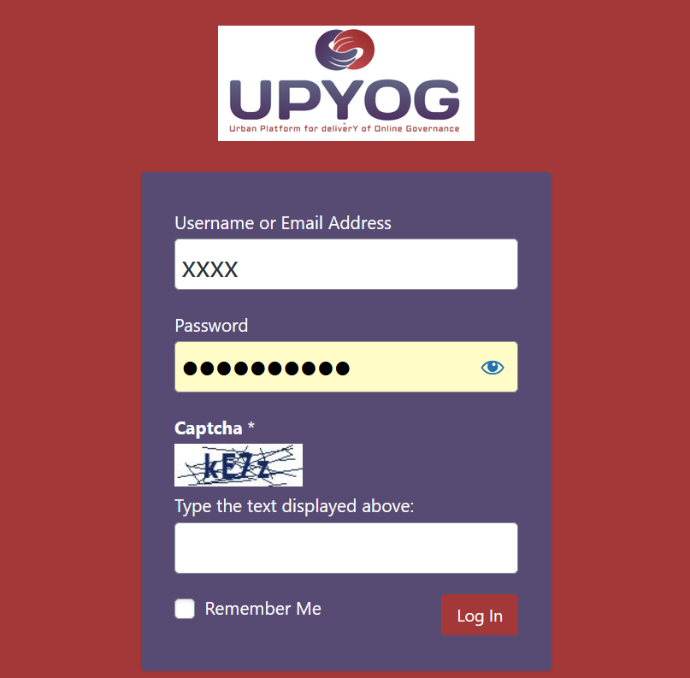

12). **After logging in, you also need to update the URL in Elementor.**

* Once you log in, the **WordPress Dashboard** will open.
* From the left-hand menu, go to **Elementor → Tools**.
* In the **Replace URL** section, enter the **Old URL** (e.g., http://15.207.2.81/upyog) and the **New URL** (e.g., https://xyz.com).
* Save the changes.

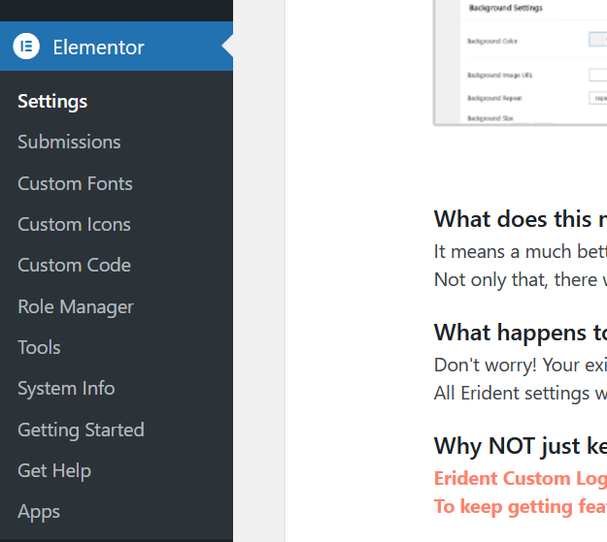

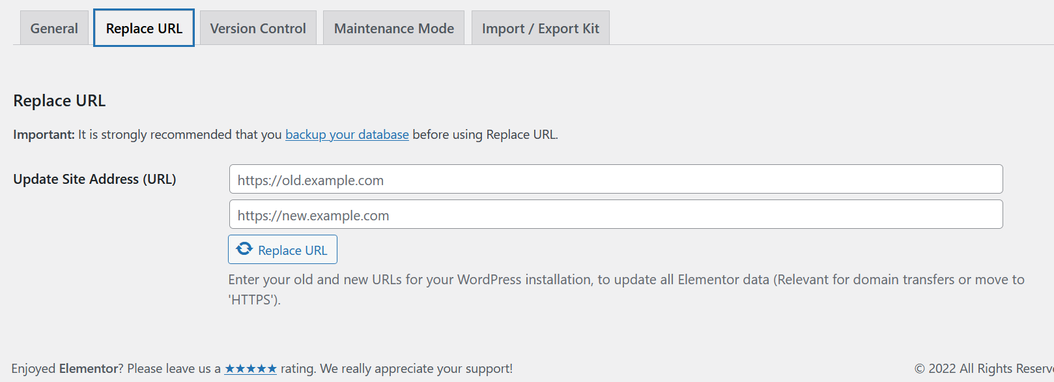

13) . **At the top of the dashboard, hover your mouse over the site name. You will see the “Visit Site” option. Click on it to view your website — your site should now be running successfully.**

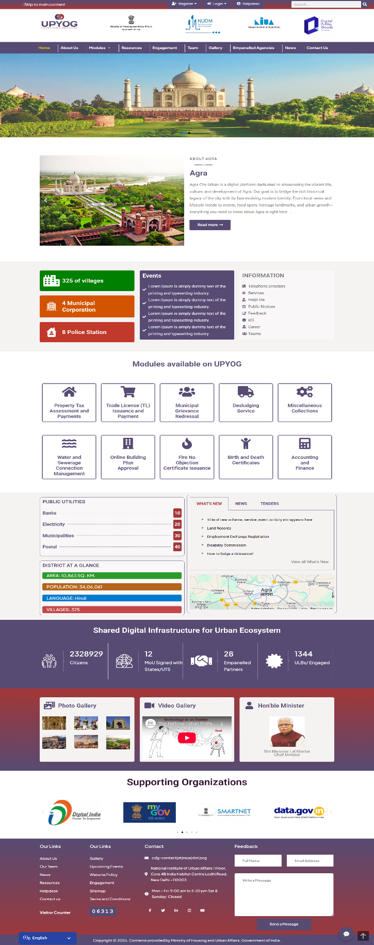

14) . **Thank you for reading the documentation**